Sprint review and Retrospective

Professor Habibi CS 250

Martin, Chloe

  DECEMBER 09, 2023

SNHU Travel Agency began a project comprised of a Scrum Team, to develop a website for its clients to book vacations based on what they preferred. These preferences ranged from top destinations to styles of vacations, i.e. cruise, plane, or ecofriendly. There were a handful of roles that together created a successful team. The roles consisted of a Scrum Master, Product Owner, Tester, and Developer. The client is considered the Stakeholder. The Scrum Master had what I consider the organizational foundation of the team. The Scrum Master, which was my designated role, was to ensure the Scrum Principles based on the Agile Methodology were implemented and followed in all steps of development. I had to ensure that all scrum events were organized and planned accordingly. These events consisted of Sprint Planning, Sprint Reviews, Daily Standups, and Retrospectives. These events allowed for team members to discuss progress, air grievances, and discuss roadblocks that have come along the way. These events and meetings were not long in duration and were contained within fifteen-to-twenty-minute windows at the start of each day. It was crucial that the meetings were not dragged on so that the timeline was not pushed further. I made sure the team understood the Agile Methodology and answered any questions during development that surrounded this form of a development process.

Moving forward, I will now discuss the Product Owner. The Product Owner was responsible for making sure we received all necessary feedback to ensure development was on par with the clients’ needs. The Project Owner had the responsibility of making sure from the beginning they were in contact with the Client. From the feedback that the Product Owner received it was relayed to me for the daily meetings and plannings during development. The Product Owner needed to be sure that the feedback was organized from most important to least important. This feedback came to me and the other members of the team in the form of User stories. User stories are designed to be informative, concise, and clear to the point of the needs of the end User. Each user story had varying needs that were broken down from most high priority to low priority, so that the developers and testers new which tasks, which were given during Sprint Planning, needed to be focused on and completed first. Below is an example of a user story that was given for feedback for the team to consider making iterative development.

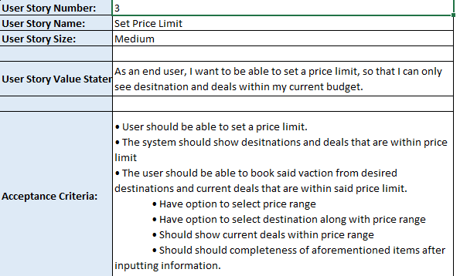

As you can see the user story breaks down what the user wanted, and what the developers and testers needed to make sure the software focused on completing. This feedback ensured that the end product was of the highest quality for our client.

Our client SNHU Travel did ask for some changes towards the projected end of development, such as making the top destinations based on wellness and detox travel destinations. Although I felt that this did not go completely with what the end user wanted, the developers were able to modify the code to the desired of SHNU Travel Agency. During the meeting team members were able to air concerns they had with this transition. The agreement came that pushing the deadline with this transition was not feasible nor was it logical, and it was best to make this transition a priority and completed quickly. Because of this shift, the use of the Agile Methodology with Scrum was crucial in maintaining. From the user stories there were already iterative changes being made to the development of the program. But with a larger shift that was not of the original focus.

***Below I have included the updated code for reference:***

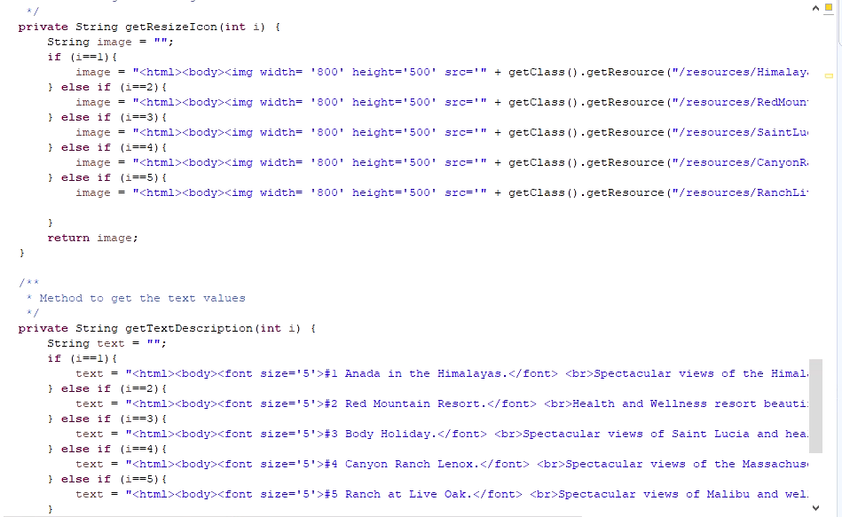

The Sprint Backlog is a real-time picture of the work that the developers of our project will plan to accomplish during the development process which is managed by the Product Owner. As mentioned before these tasks are prioritized and the Product Owner has the responsibility of making sure that the backlog is kept in order to make sure that the team remains focused on target tasks.

During development the testers needed to update the provided test cases that were based on the user stories.

As you can see the user stories were more of an overview of the users needs and from there the testers updated the user stories to a test case with expected results. These test cases were guidelines that should have met a specific goal for each test case. This was a vital step in the development process and ensuring that the feedback and updated stories occurred from the earliest steps was a focal point for the testers.

Our developers had the responsibility of using all user stories, feedback of test cases, and all information from test meetings to make sure that the system is functioning properly for the SNHU travel project. These user stories, test cases, and meetings gave the much-needed information the developers needed to meet all requirements and goals. The developer also needed to make sure there was open and transparent communication with the team. This was demonstrated in the change of the code that was provided earlier in this analysis.

The use of the Scrum-Agile approach for the SNHU Travel Agency project was an overall success, regardless of the possible setbacks considered. As Scrum Master ensuring the Agile principles were followed and prioritized helped with the overall success. Ensuring that we had face-to-face meetings, daily meetings, and tasks to complete was the largest benefit I brought forth to the Scrum Team. The use of emails and open communication ensured that all tasks were addressed for a successful completion. Below is the email that was sent to address some concerns and questions that required answers from the tester to the Product Owner in regard to the user stories and clarification. This email shows how open communication was within the team.

The foundation of Agile Methodology is flexibility. This was the best course for the SNHU Travel Agency Project. Due to the changes needed from feedback and testing, and the last-minute overhaul of the program needed, a waterfall approach would not have sufficed. This approach allowed for iterative changes to the development process, one that cannot be done with the full build of a program with no changes allowed. The best choice was made for the project by implementing a Scrum Team and Agile Methodology. The added tasks were in the fact the biggest cons of the development process, but because of the strong understanding the team had of the principles of Agile and the processes that follow thereafter allowed for the completion of a successful end product for the client and end users.

REFERENCES

Cobb, Charles G. The Project Manager's Guide to Mastering Agile: Principles and Practices for

an Adaptive Approach. Hoboken: Wiley, 2015.

Cobb, Charles G. The Project Manager's Guide to Mastering Agile: Principles and Practices for

an Adaptive Approach. Hoboken: Wiley, 2015.

Cobb, Charles G. The Project Manager's Guide to Mastering Agile: Principles and Practices for

an Adaptive Approach. Hoboken: Wiley, 2015.

Cobb, Charles G. The Project Manager's Guide to Mastering Agile: Principles and Practices for an Adaptive Approach. Hoboken: Wiley, 2015.